





**Activity 3**

* **Github team link:**

[**https://github.com/DiegoAndresMantilla/Team3DevSolutions**](https://github.com/DiegoAndresMantilla/Team3DevSolutions)

* **Link to the video presentation of the project:**

[**https://youtu.be/Dex1lWhgE7E**](https://youtu.be/Dex1lWhgE7E)

**Screenshots of the evaluation parameters:**

1. **Github repository (Structure)**

**1.1 Structure:**

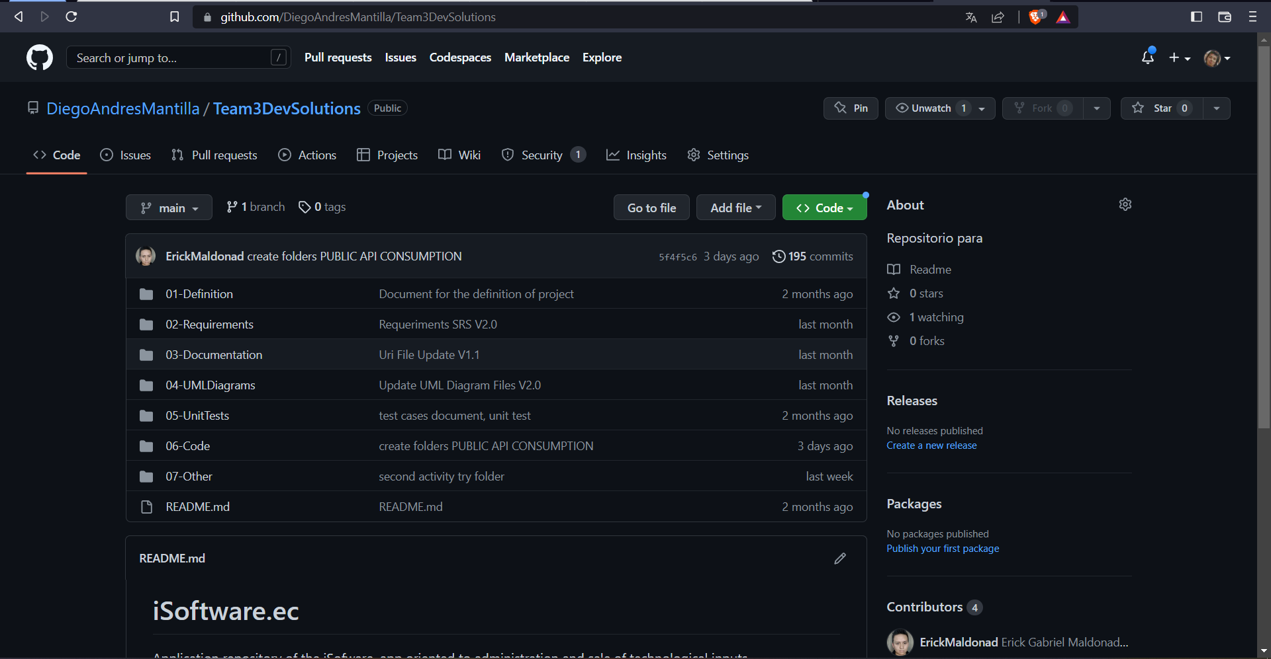

**1.2 Commits:**

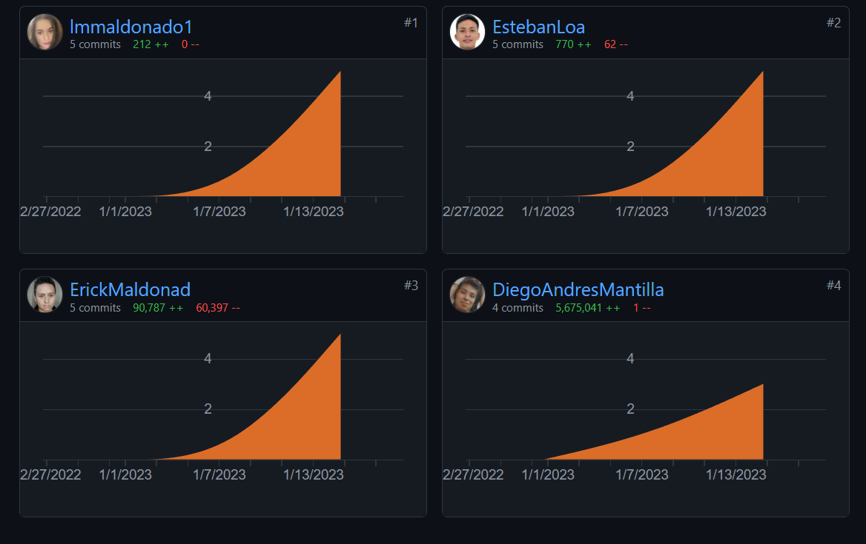

1. **Design (sketches) of the web pages**

**Page Principal**

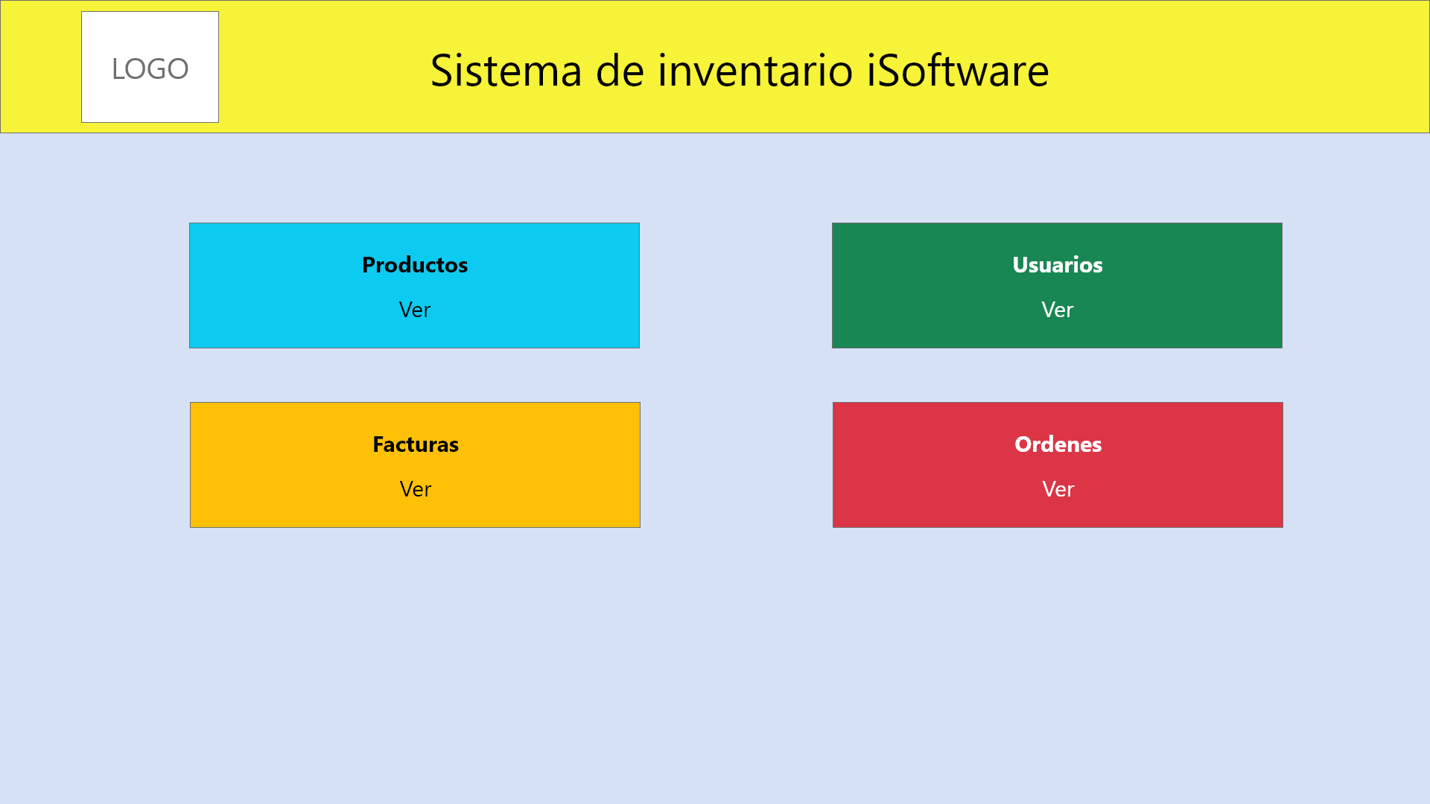

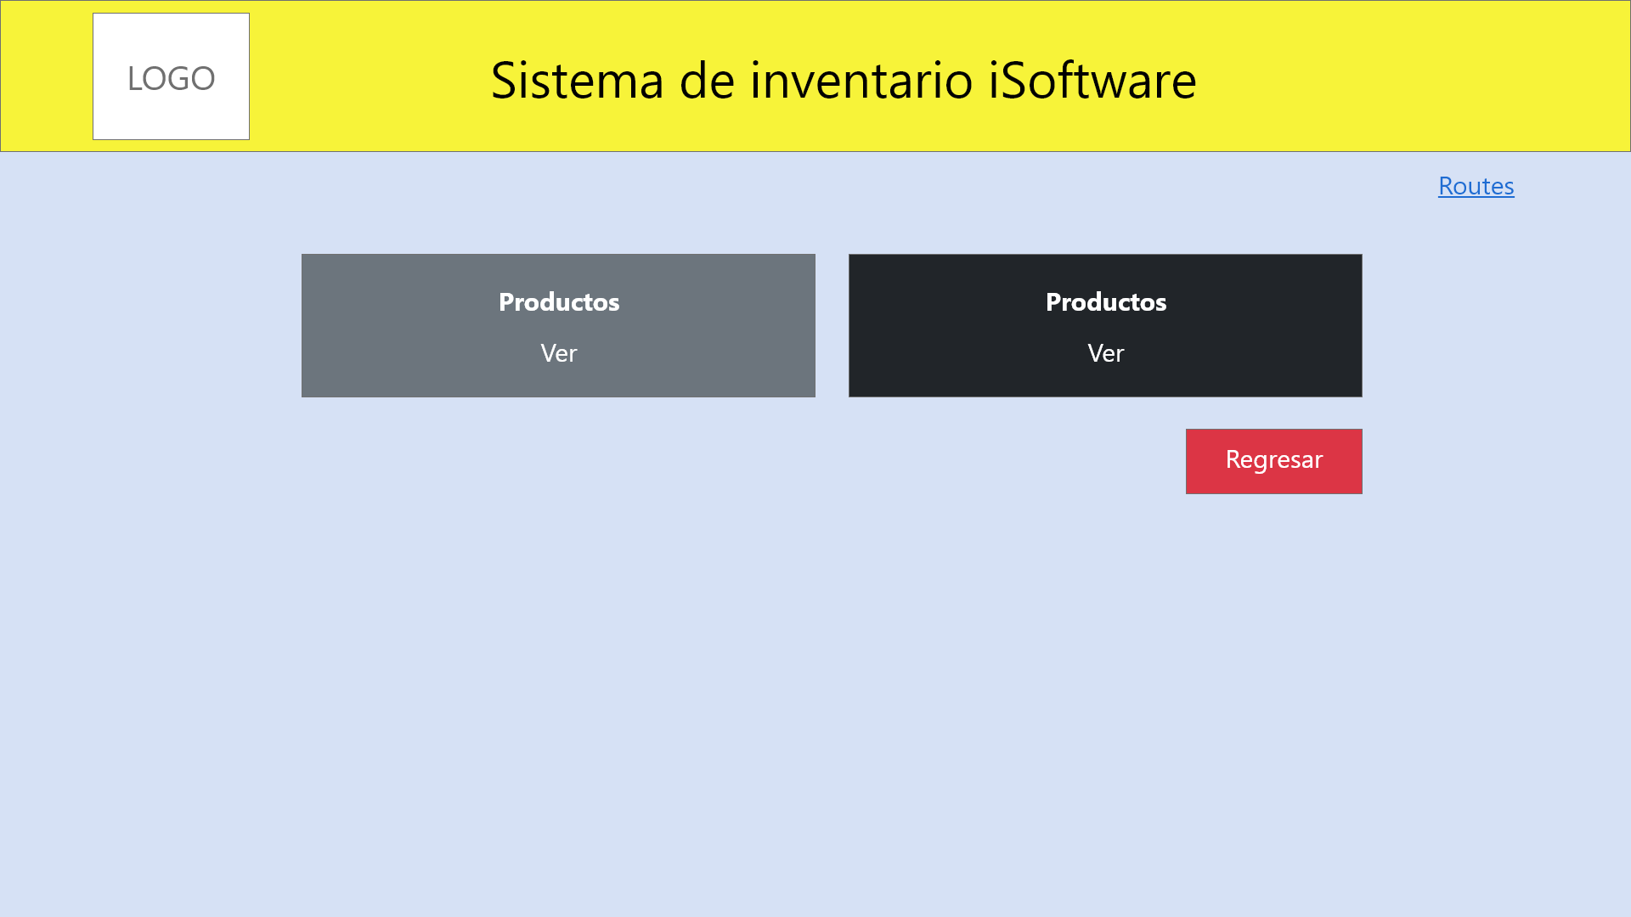

**Consumption page Api Products**

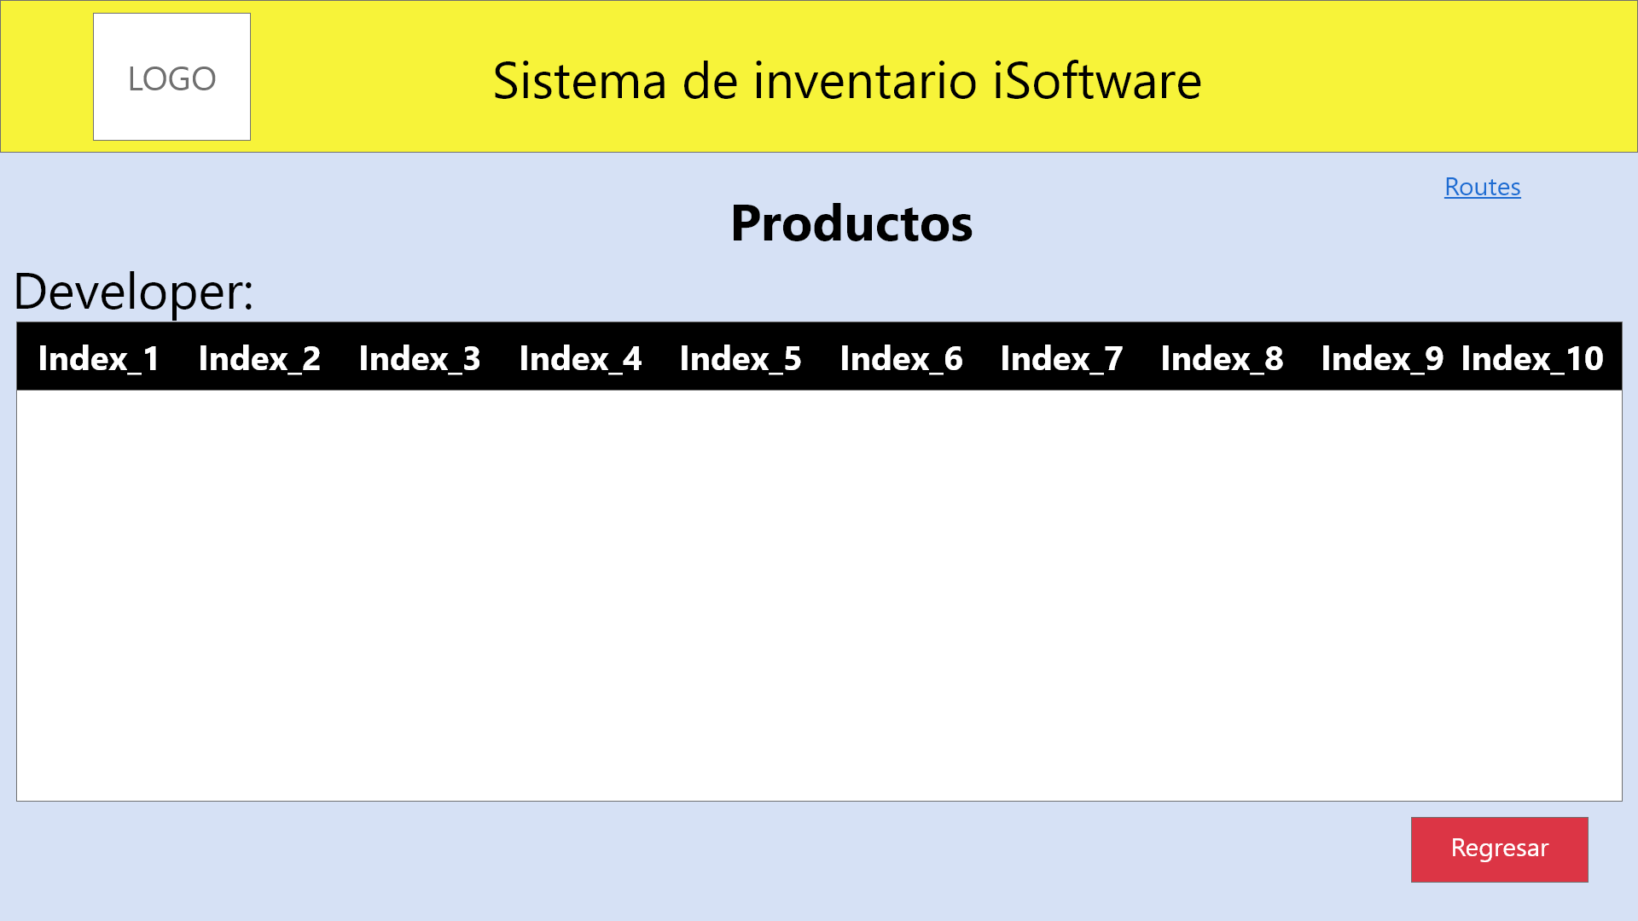

**Page add Products**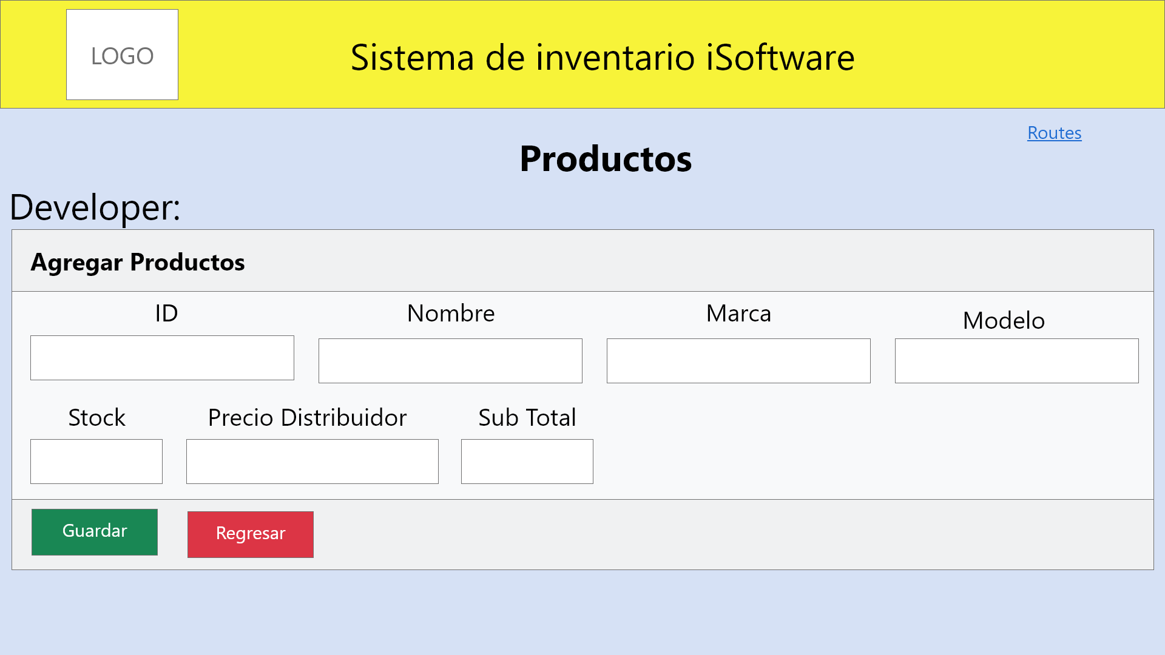

**Consumption api Users**

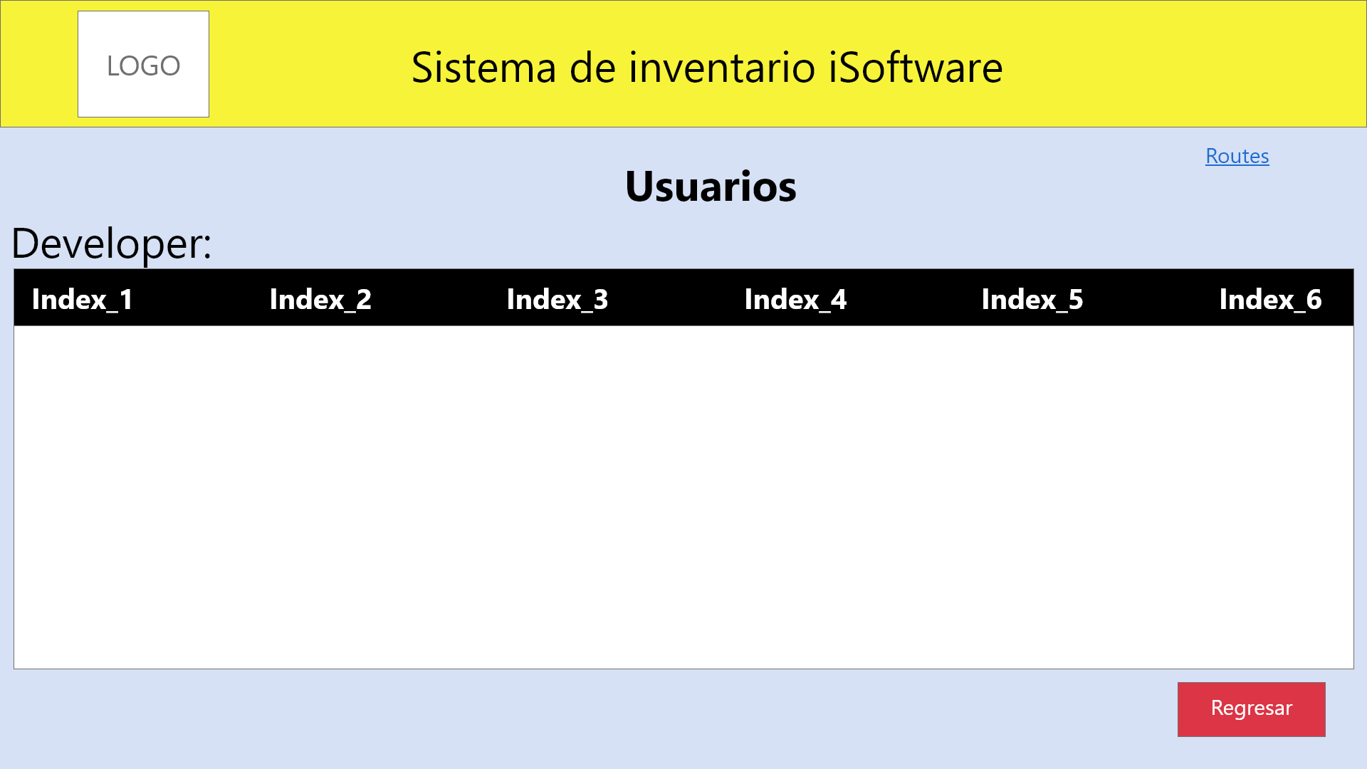

**Page add Users**

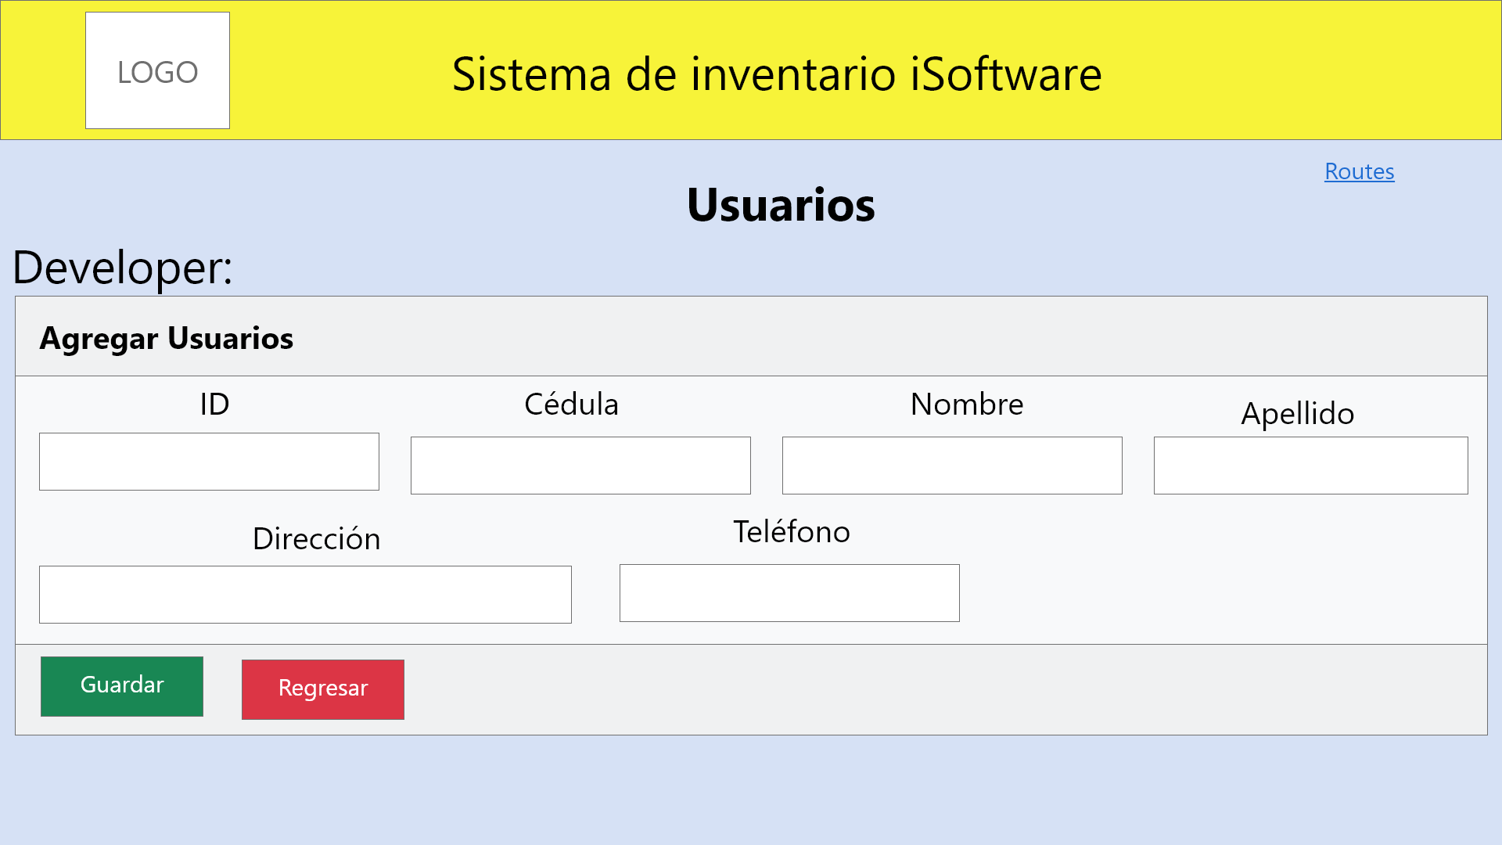

**Consumption api Invoices**

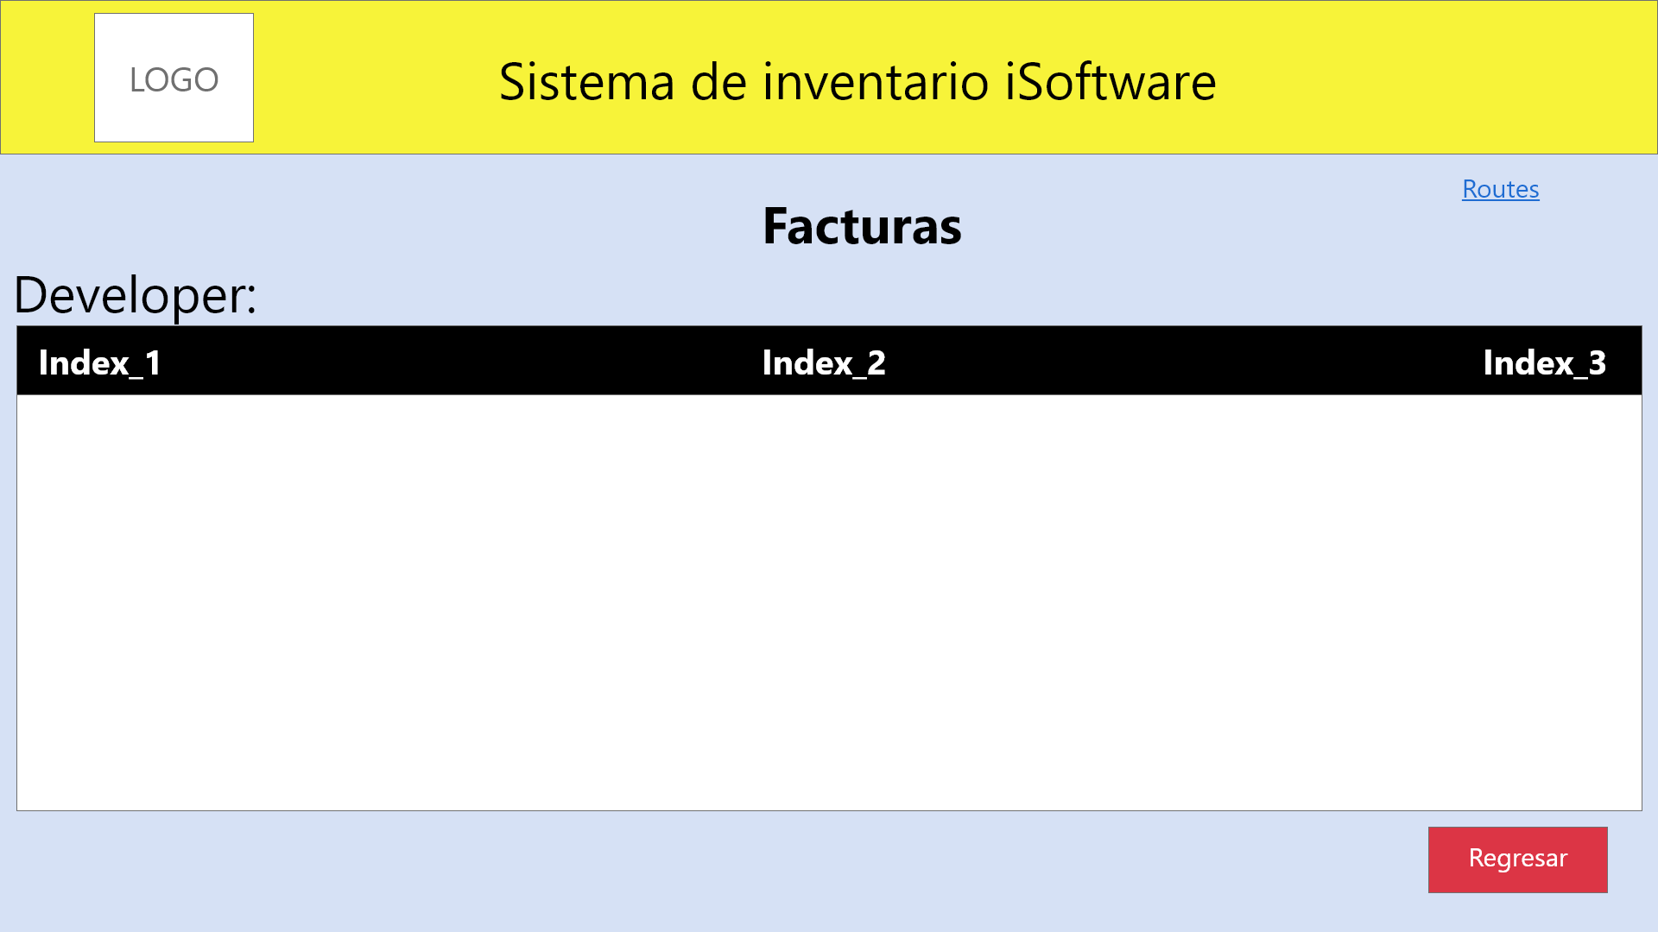

**Page add Invoices**

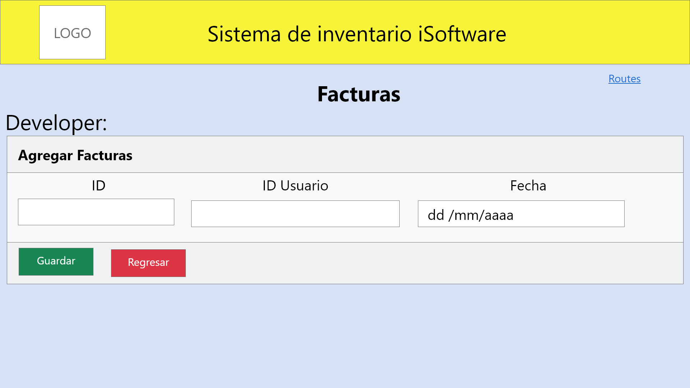

**Consumption api Orders**

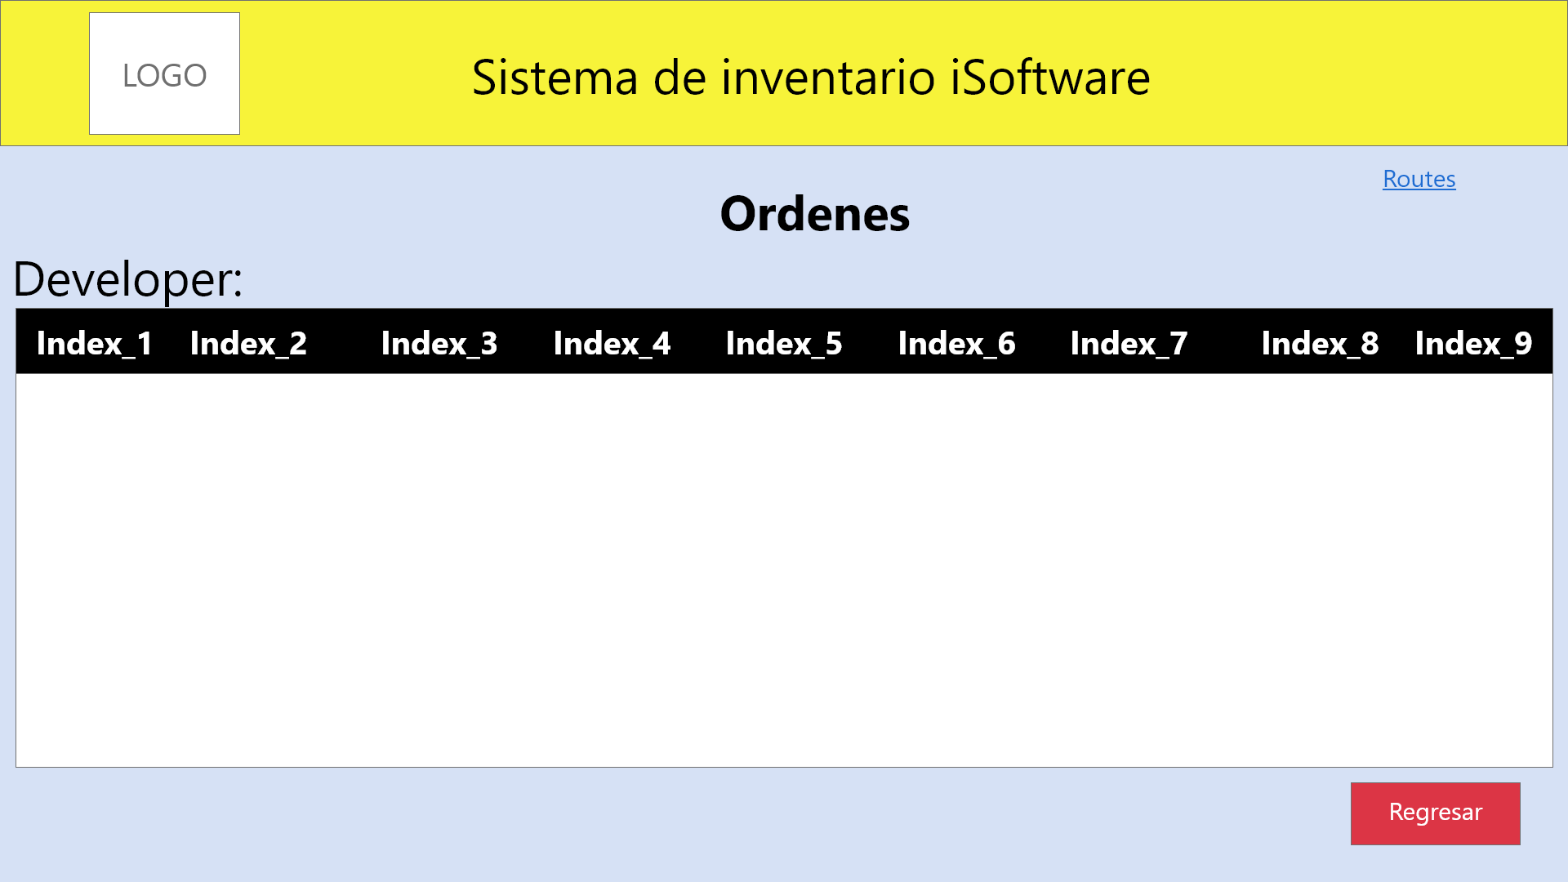

**Page add Orders**

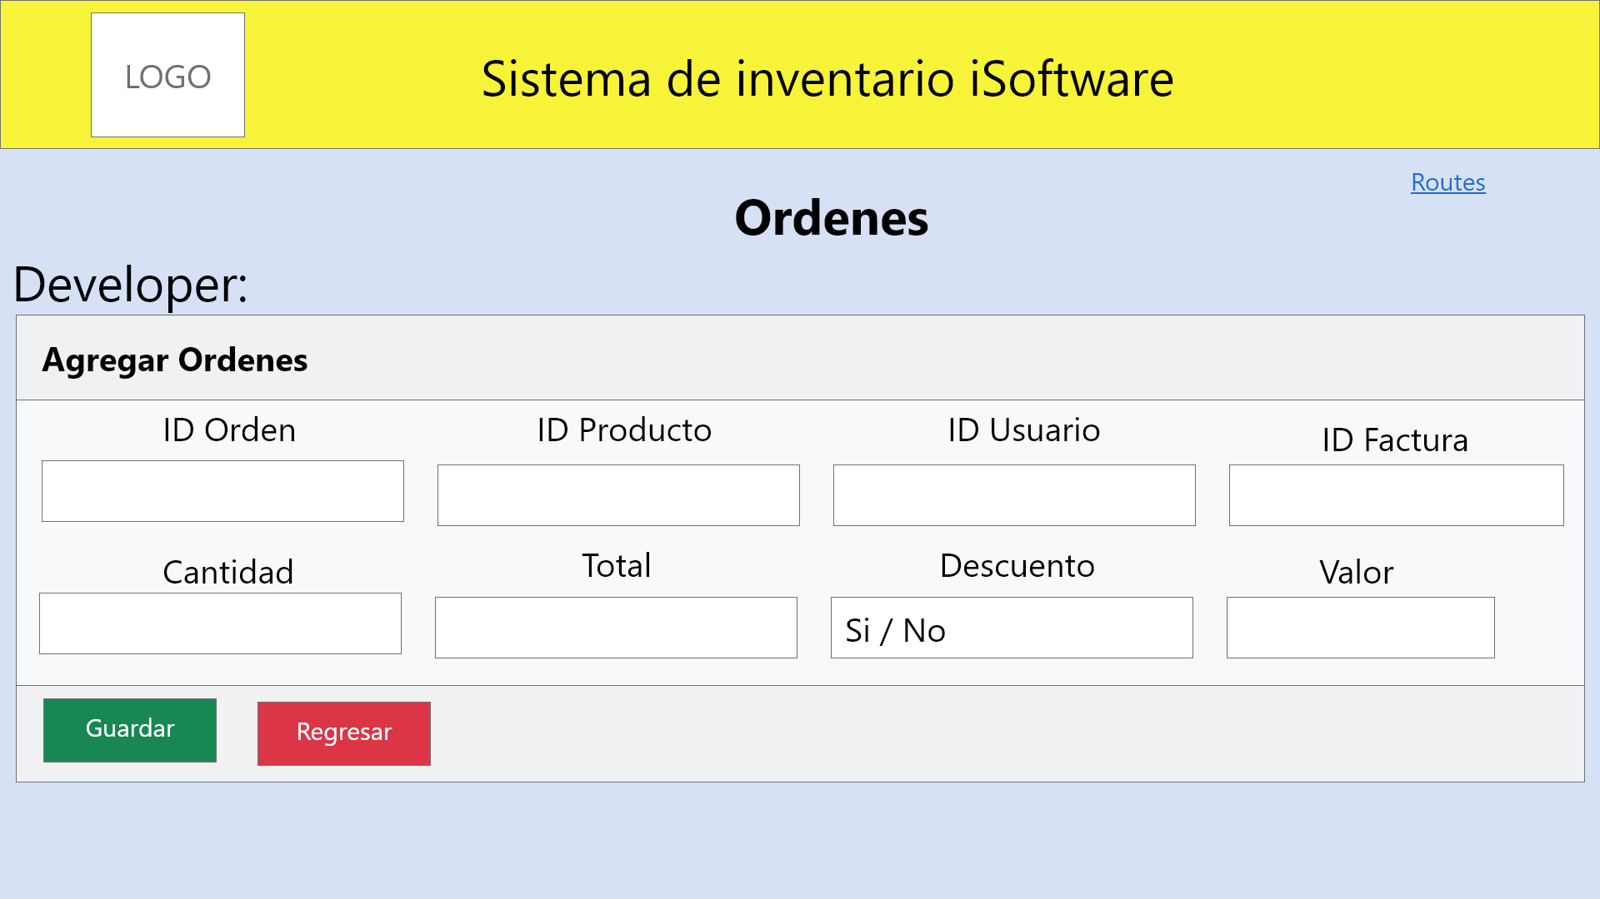

1. **Authentication and Navigability (sessions)**

**Navigation Front-End iSoftware - Code Routes**

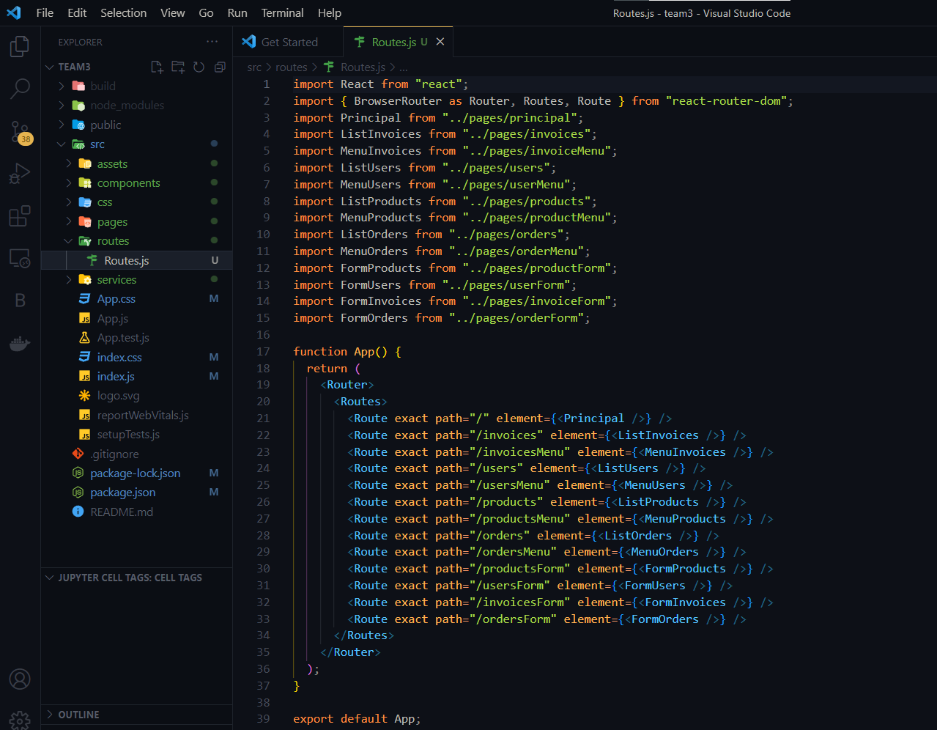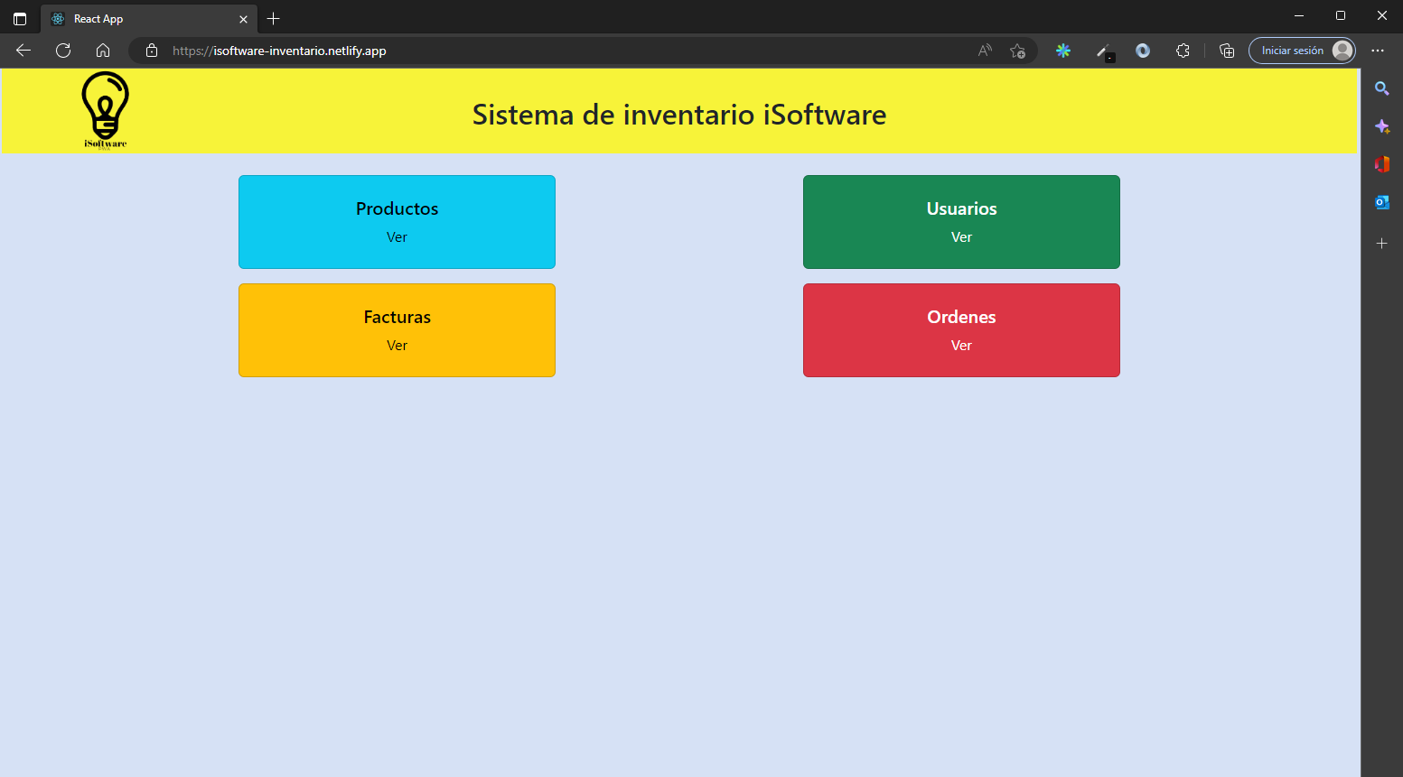

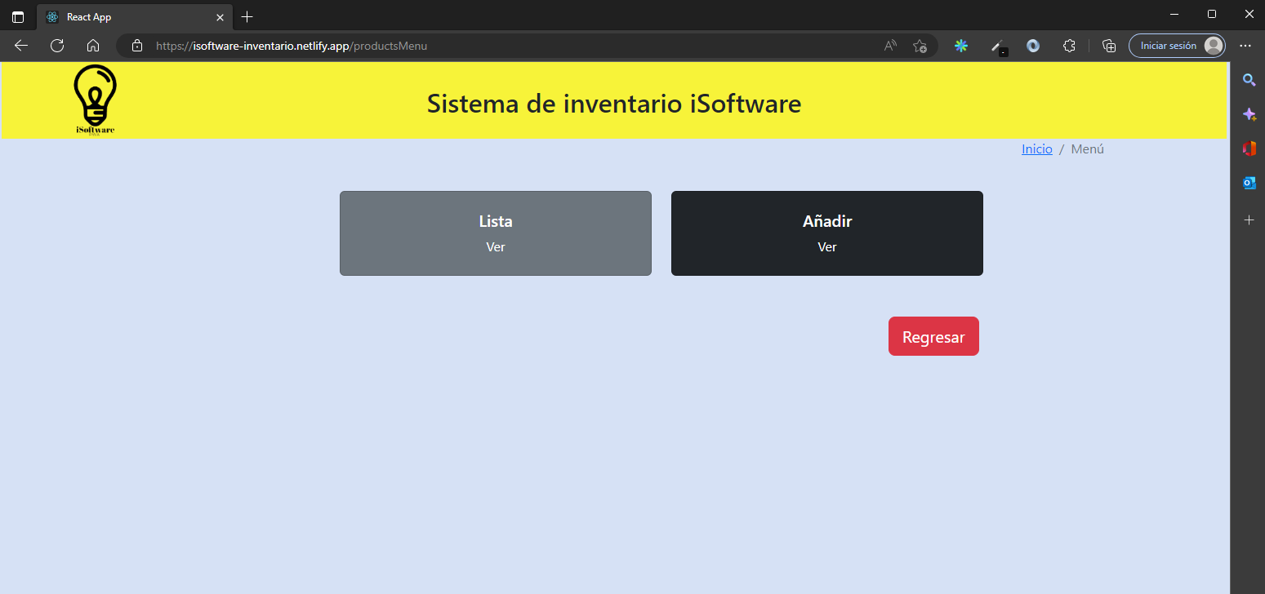

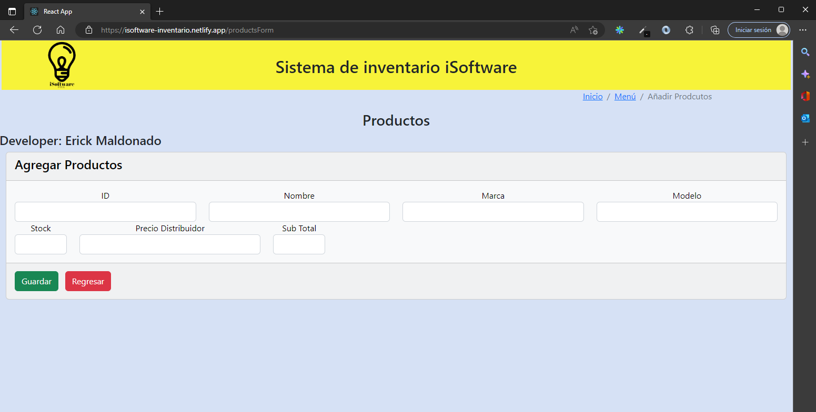

1. **Web Clients + public API** [**https://api.plos.org/search**](https://api.plos.org/search)
   1. **Web Clients:**

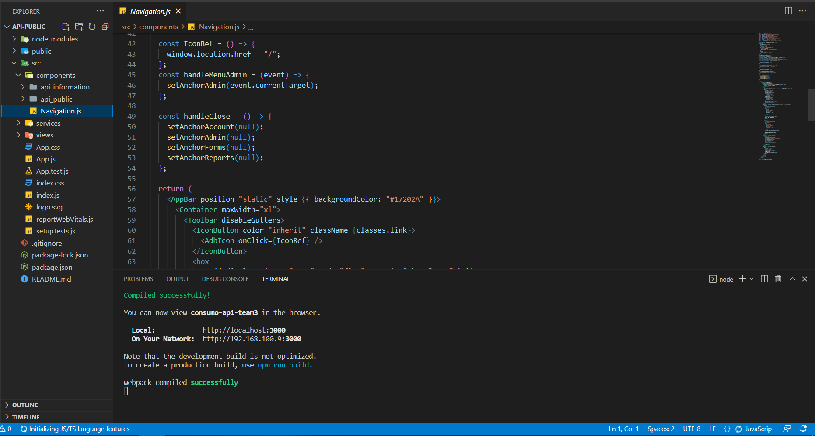

* 1. **Public API:**

**Link App:**

[**https://devsolutions-espe.netlify.app/**](https://devsolutions-espe.netlify.app/)

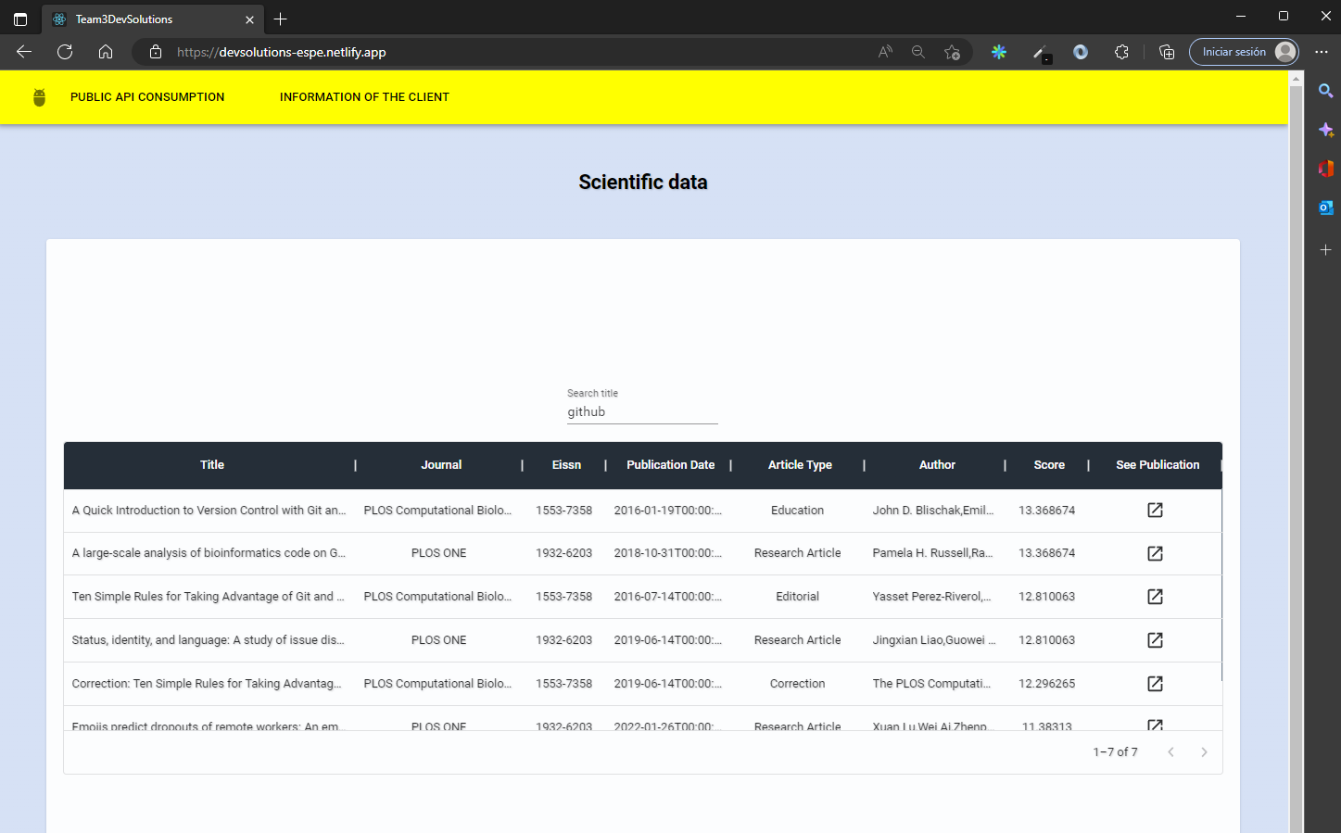

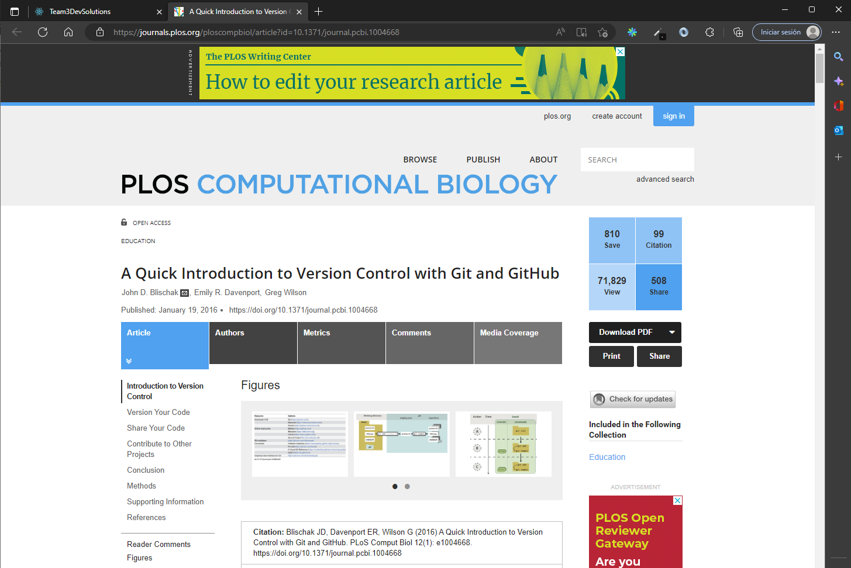

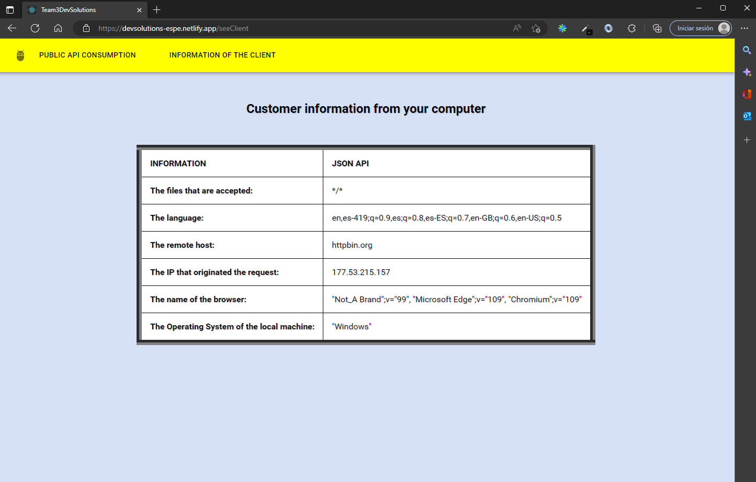

1. **Web Clients + Web Service + BDD**
   1. **Web Clients**

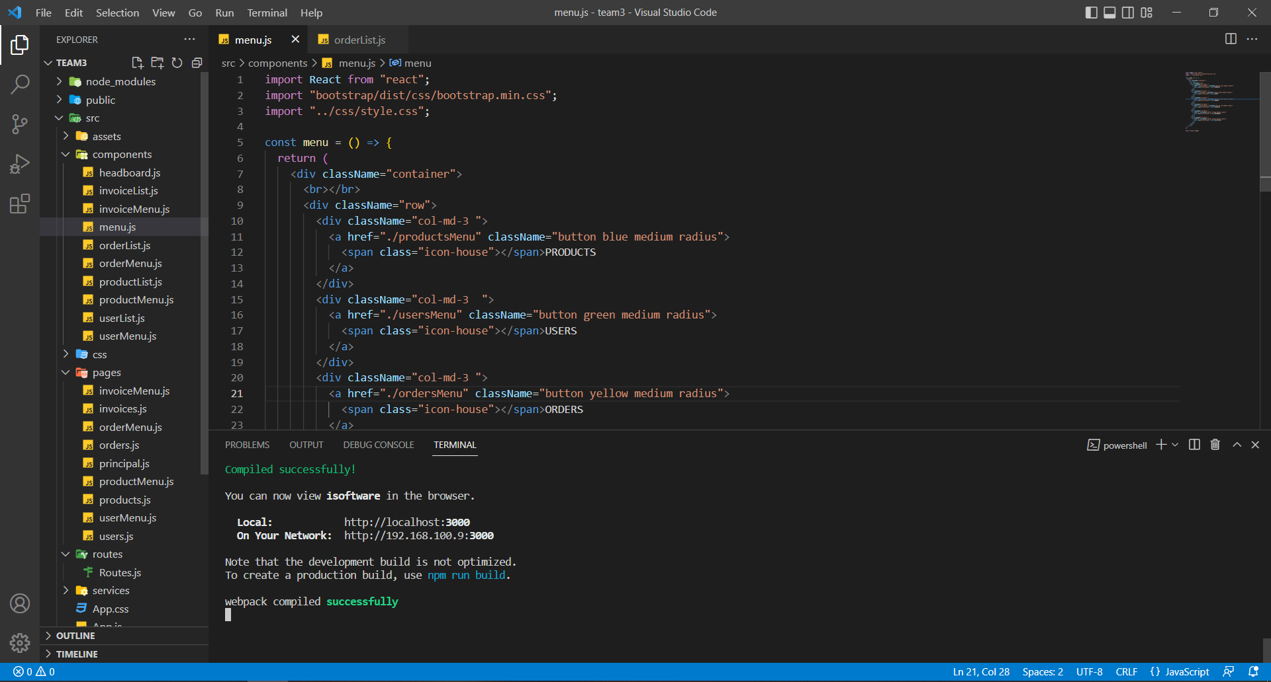

* 1. **Web Service**

**Link App:**

[**http://isoftware-inventario.netlify.app/**](http://isoftware-inventario.netlify.app/)

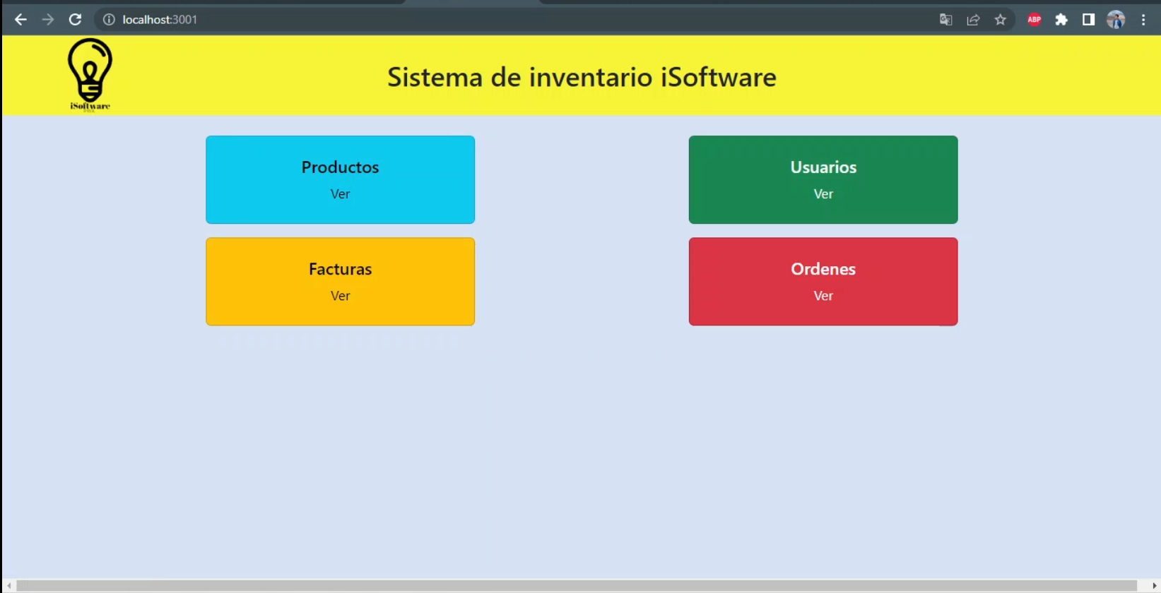

**Consumption URI Products:** [**44.211.70.232:3003/iSoftware/listProducts**](http://44.211.70.232:3003/iSoftware/listProducts)

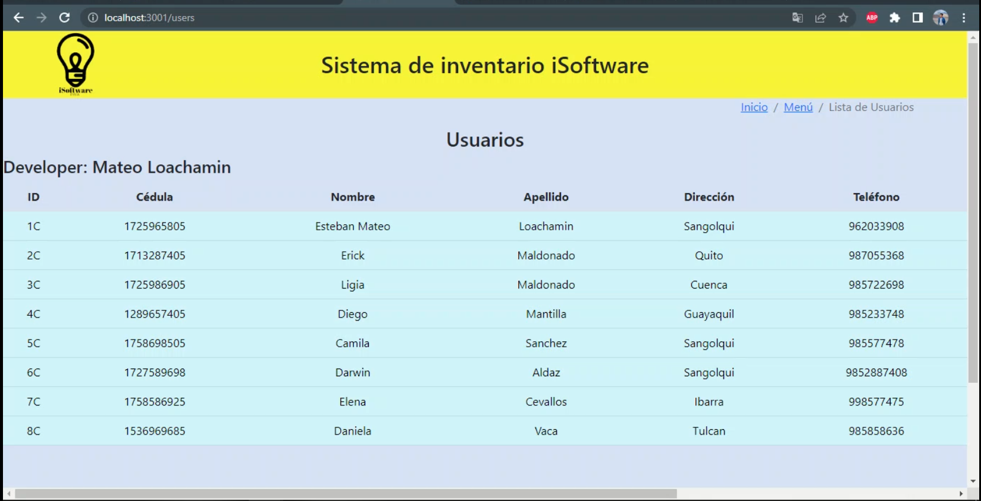

* 1. **BDD**

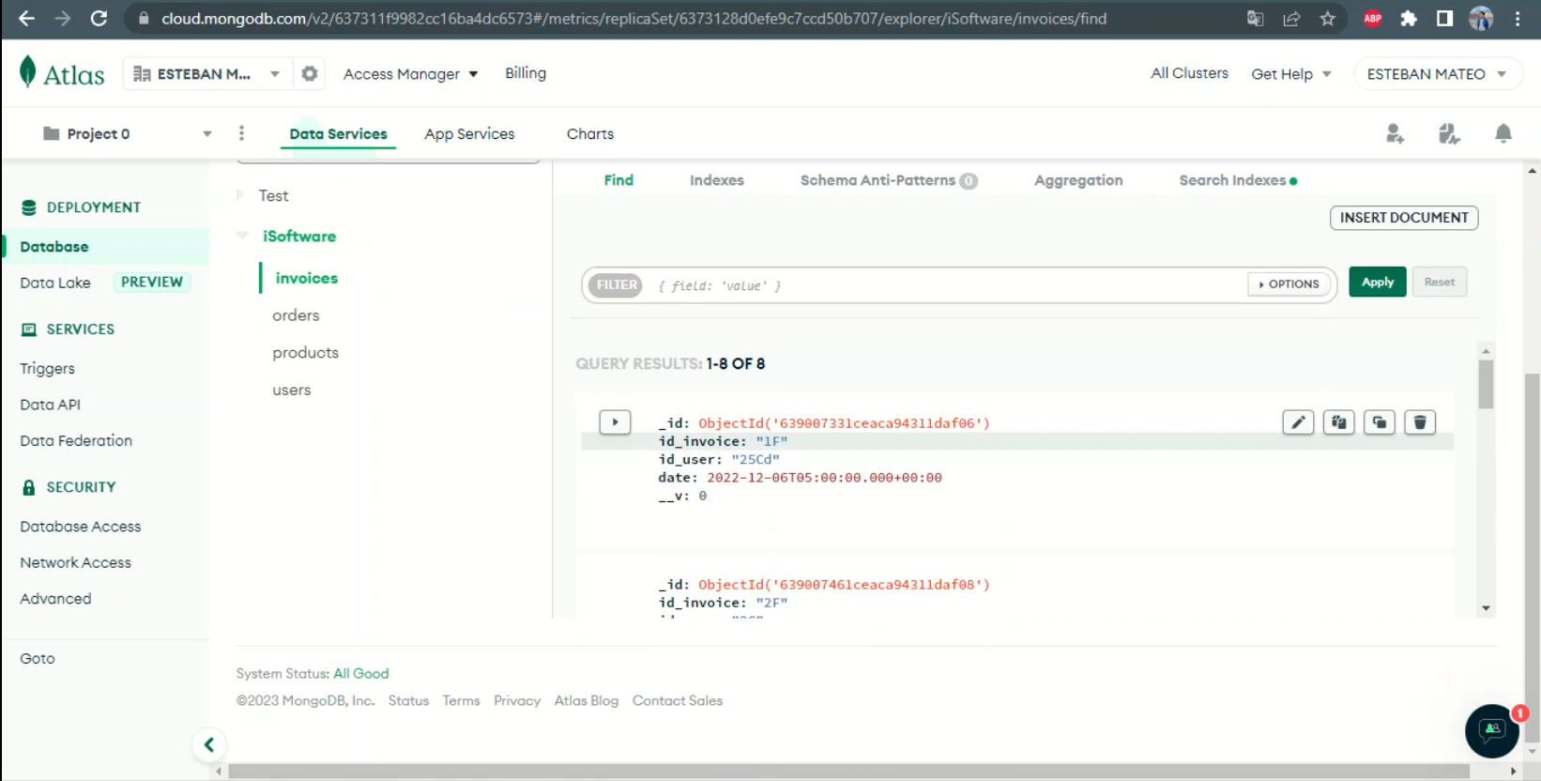

1. **Other web pages / forms for the project**

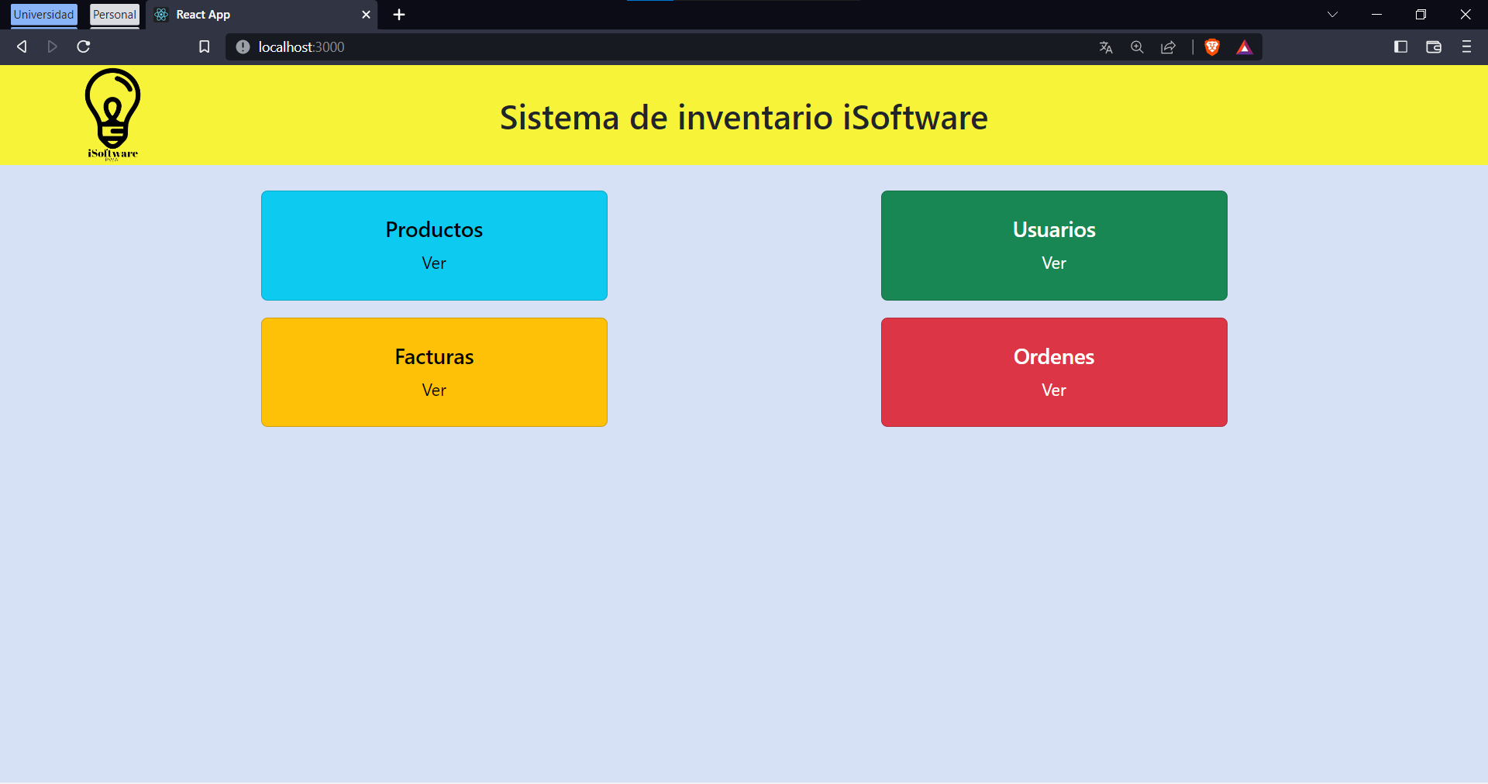

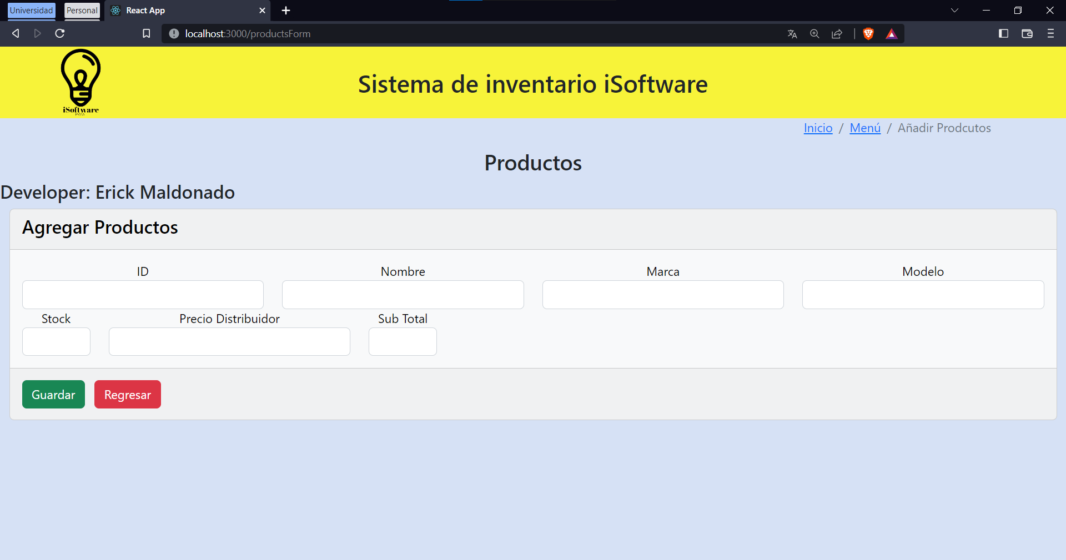

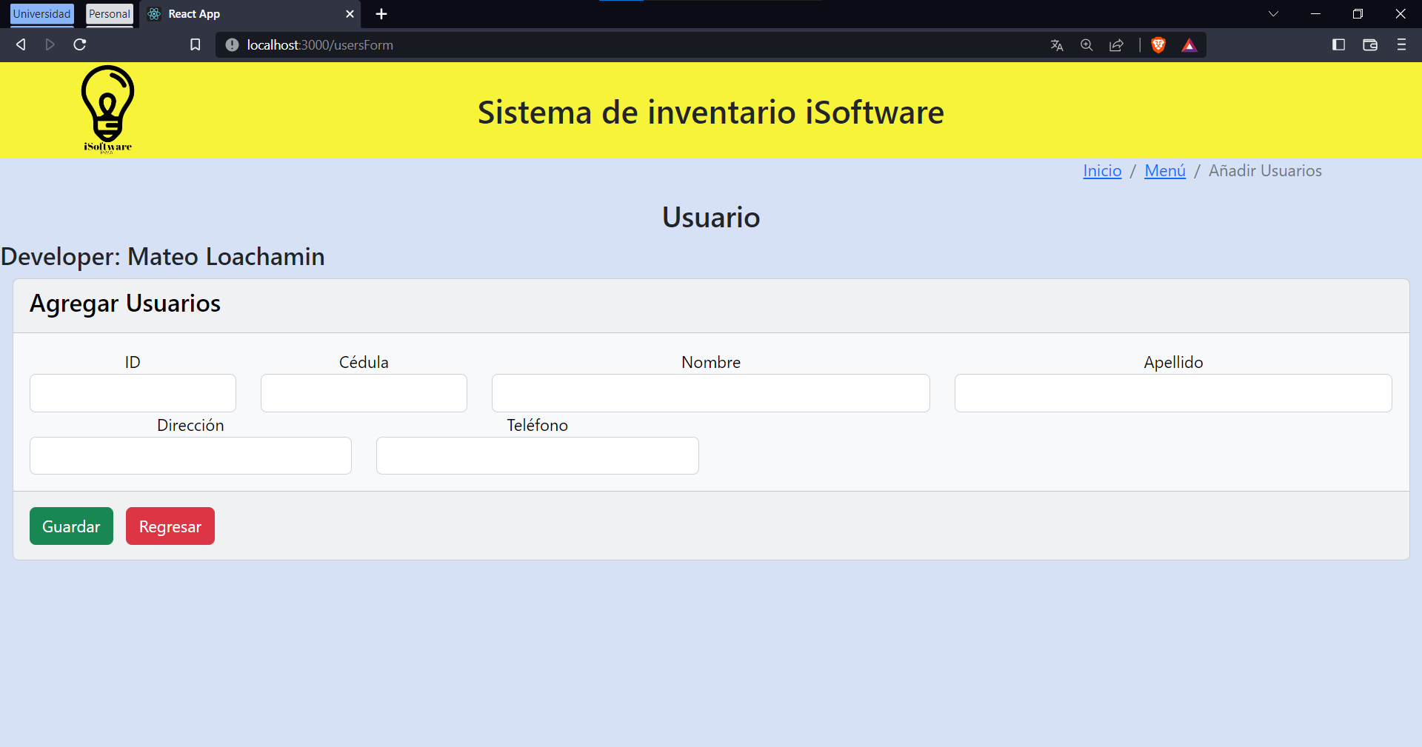

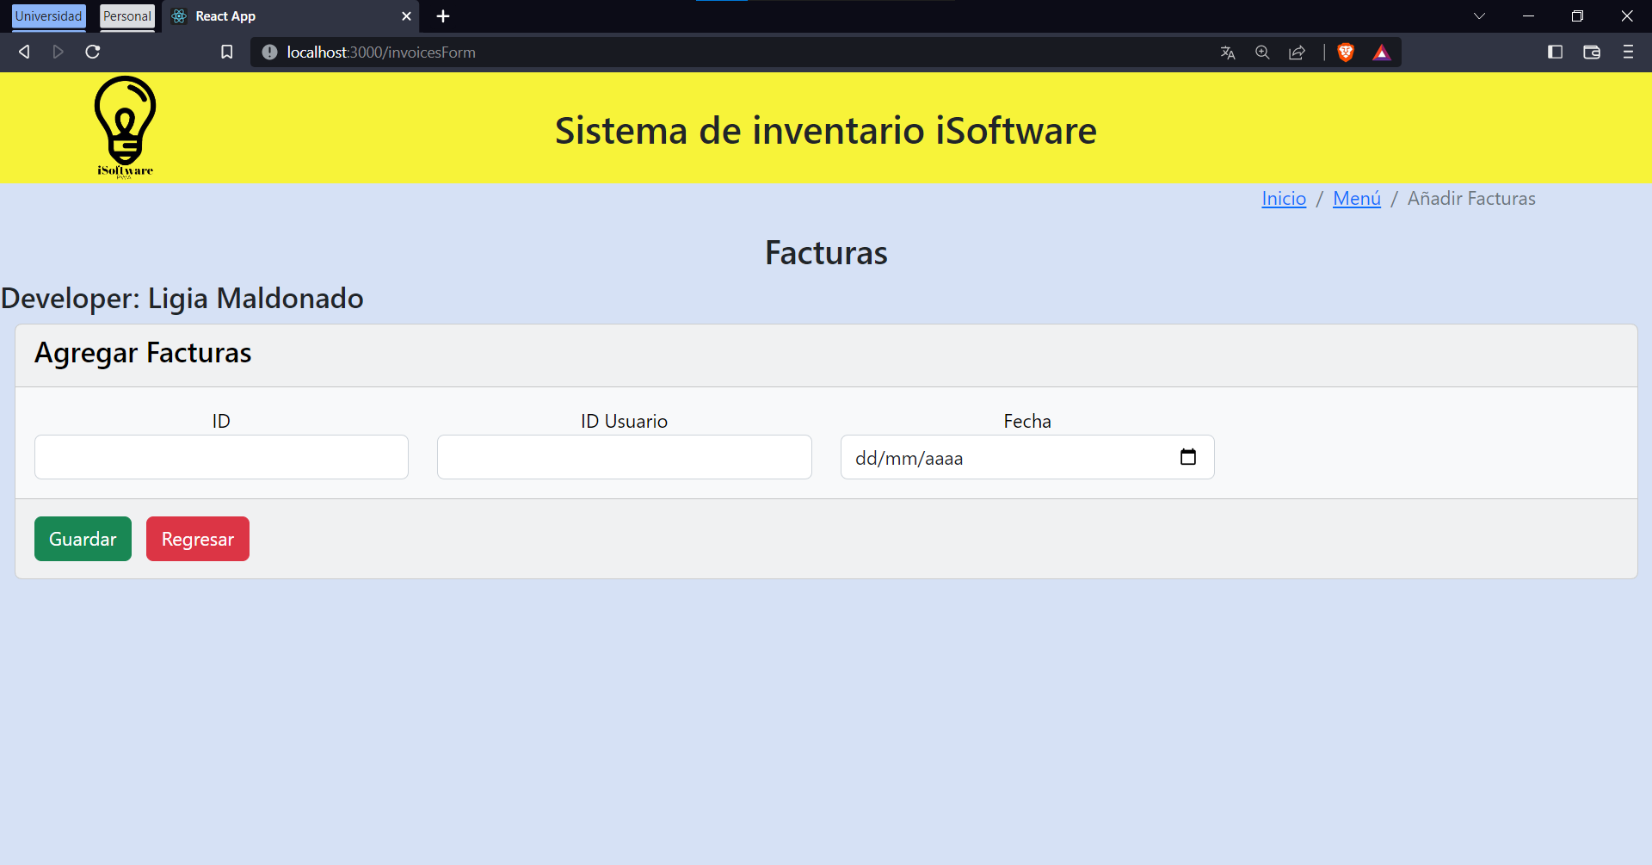

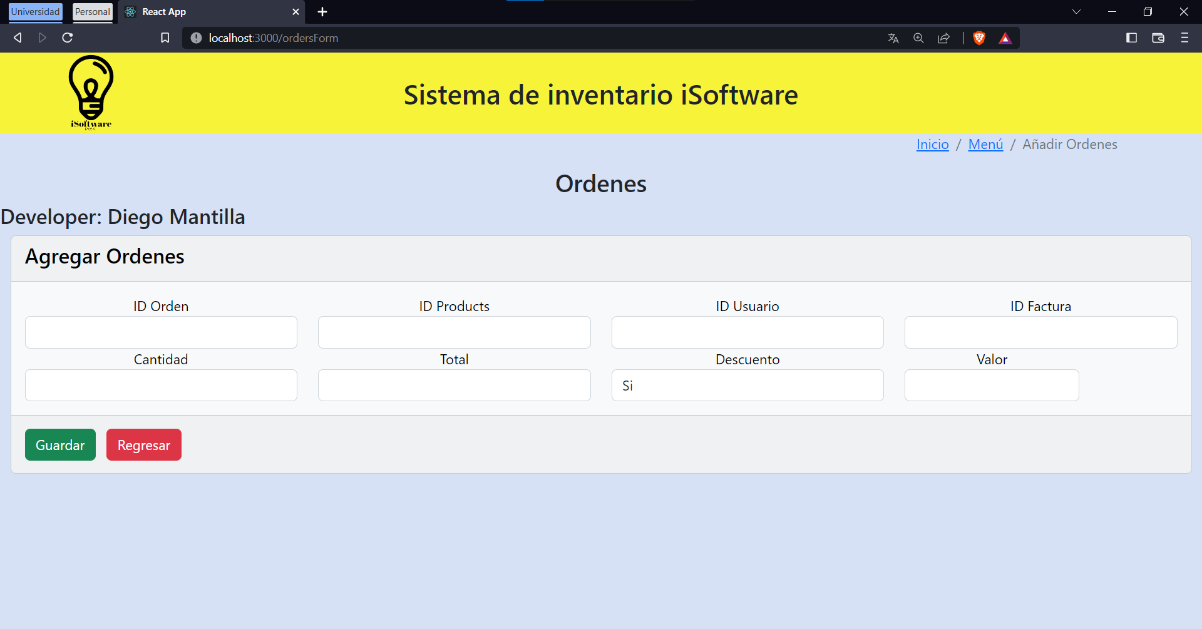

**Validation report:**

* **Esteban Loachamin:** Users & Sessions

Well done, some difficult trying to apply the sessions requirement, also, good ideas to the cc styles of the buttons and pages. Time expended: 4-5 days.

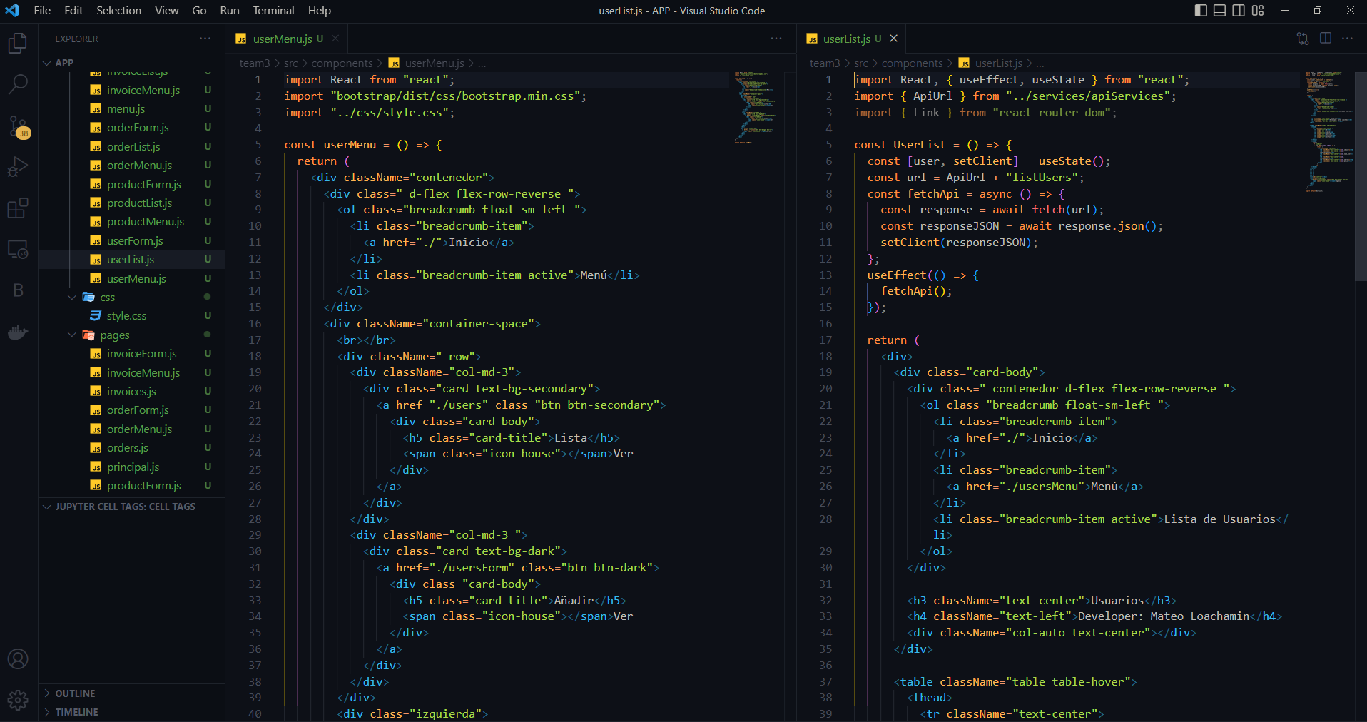

* **Erick Maldonado:** Products & Public API

Excellent ideas, principal builder of the public API part, and helper to solve some errors and warnings about the project. Time expended: 4-5 days.

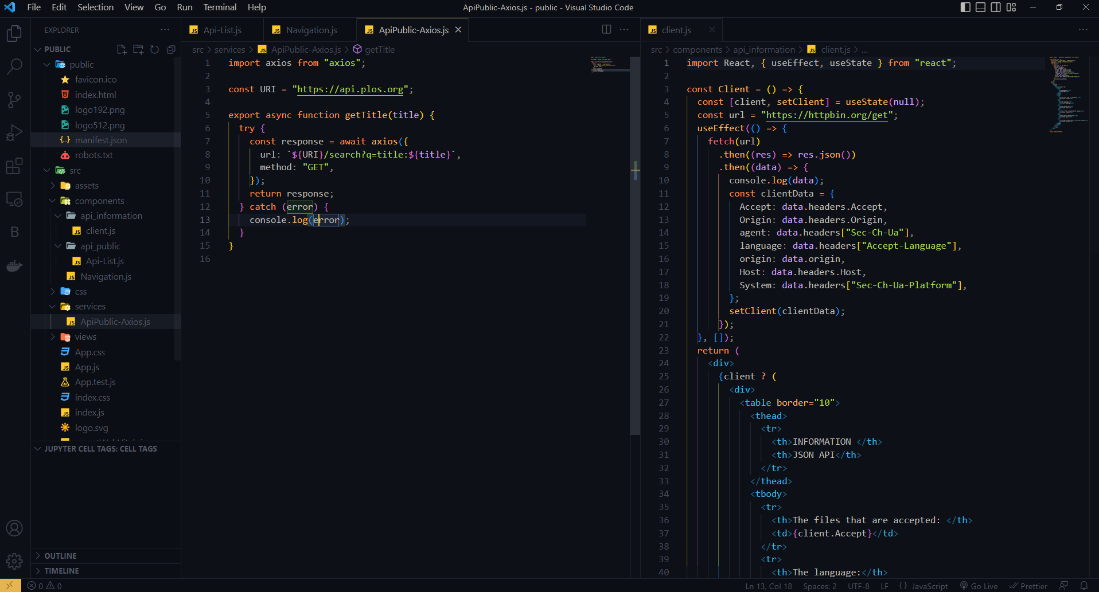

* **Ligia Maldonado:** Invoices & UML

Good job, well explained UML’s, the invoice pages give a principal idea to do in the other pages and routes. Time expended: 4-5 days.

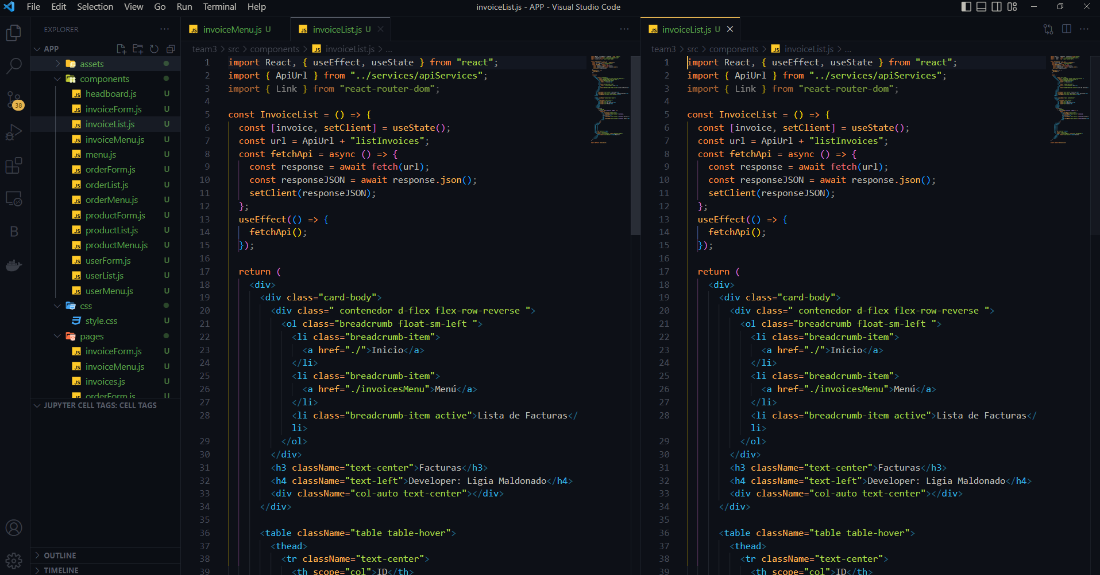

* **Diego Mantilla:** Orders & Sub-menús.

Good, giving some ideas to use multiple routes to the pages, helping with the API navigation and building the templates of the pages to build in the code. Time expended: 4-5 days.

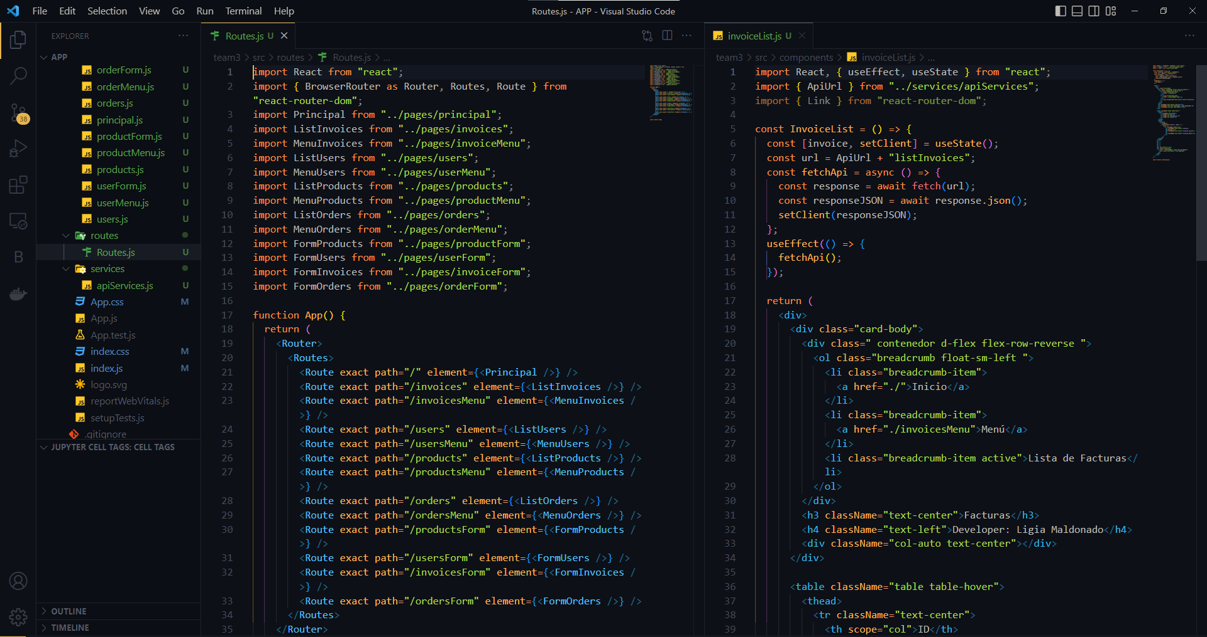

**Rubric**

**1. Github Repository (Right Structure and collaboration) /1**

**2. Design (sketches) of the web pages /0.5**

**3. Authentication and Navigability (sessions) /0.5**

**4. Web Clients + public API https://api.plos.org/search /0.5**

**5. Web Clients + Web Service + BDD /0.5**

**6. Other web pages / forms for the project /1**

**_______________________________________________________**

**GRADE: /**